From: https://slate.com/news-and-politics/2018/09/new-york-times-op-ed-anonymous-writer-trump.html

The Obvious Suspect

The quest to unmask the New York Times op-ed writer has been filled with speculation. But the article’s prose points to one person in particular.
By WILLIAM SALETAN
SEPT 07, 20181:15 PM

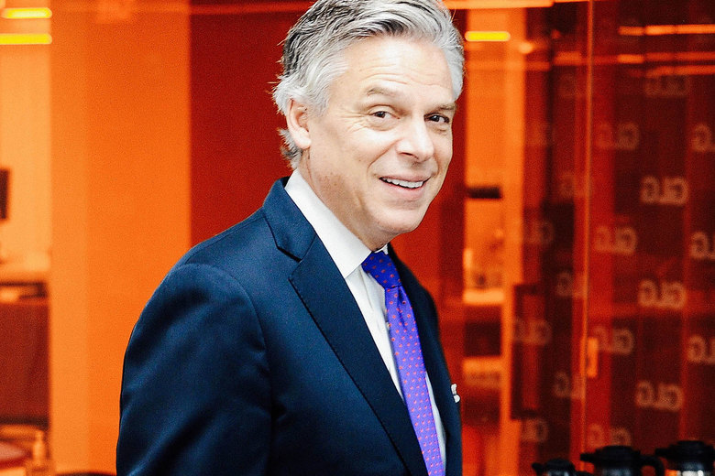
Jon Huntsman visits Gerson Lehrman Group on Dec. 2, 2014.
Photo by Andrew Toth/Getty Images for GLG
Who wrote the anonymous op-ed against President Trump in Wednesday’s New York Times? All we know for certain is what the Times disclosed: that it’s a “senior official in the Trump administration.” But the most likely author, based on the op-ed’s content and style, is the U.S. ambassador to Russia, Jon Huntsman.
Huntsman is an obvious suspect for several reasons. The article’s themes are classic Huntsman: effusive about conservative policies, blunt about low character. In 2016, he made the same points for and against Trump. The topic that gets the most space and detail in the piece is Huntsman’s current area, Russia. (As Slate’s Fred Kaplan points out, Trump has been circumventing and undermining Huntsman.) The prose, as in Huntsman’s speeches and interviews, is flamboyantly erudite. The tone, like Huntsman’s, is pious. And the article’s stated motive—“Americans should know that there are adults in the room”—matches a letter that Huntsman wrote to the Salt Lake Tribune in July. In the letter, Huntsman, responding to a columnist who thought the ambassador should resign rather than keep working for Trump, explained that public servants such as himself were dutifully attending to the nation’s business.
Like other suspects, Huntsman has issued a statement to deflect accusations that he wrote the Times op-ed. But the statement—actually just a tweet—doesn’t come from Huntsman. It comes from the spokesperson at the U.S. Embassy in Moscow. The full text reads, “Amb Huntsman: Come to find, when you’re serving as the U.S. envoy in Moscow, you’re an easy target on all sides. Anything sent out by me would have carried my name. An early political lesson I learned: never send an anonymous op-ed.”
That’s a non-denial denial. The Times has already said that the author’s “identity is known to us.” So the piece can’t have been sent anonymously. It must have carried the author’s name. Which means the statement from Huntsman’s spokesperson is technically accurate, even if he wrote the piece. And no matter what he says, he’s still the most likely suspect—at least until somebody else steps forward to claim responsibility—because the piece is full of telltale words and phrases. Here are some of them.
Country first. The op-ed glorifies the late Sen. John McCain. It calls him a “lodestar,” the word used by Henry Kissinger at McCain’s Sept. 1 memorial service to describe the senator. It concludes with this line: “There is a quiet resistance within the administration of people choosing to put country first.” “Country first” was McCain’s presidential campaign slogan in 2008. Huntsman, who idolized McCain, adopted the same slogan for his 2012 presidential campaign. A week ago, after McCain died, Huntsman lauded McCain as his mentor and recalled his motto, “Country first.” Huntsman also flew back from Moscow to attend the memorial service.
Malign. The op-ed aims its most specific criticism at Trump’s coddling of Vladimir Putin:
On Russia, for instance, the president was reluctant to expel so many of Mr. Putin’s spies as punishment for the poisoning of a former Russian spy in Britain. He complained for weeks about senior staff members letting him get boxed into further confrontation with Russia, and he expressed frustration that the United States continued to impose sanctions on the country for its malign behavior.
That’s a lot of detail about what Trump said and did. It’s exactly the subject on which Huntsman would be most likely to get good inside information. In addition, malign—which is fancier and more correct in this context than the more popular term malignant—is one of Huntsman’s favorite words, especially when talking about Russia. Last year, at his confirmation hearing, Huntsman repeatedly denounced Russia’s “malign activity.” This summer, in briefings and interviews leading up to the July 16 summit between Trump and Putin, Huntsman criticized Russia’s “malign activity,” “malign activities,” and “malign events.” He used the word so profusely that Chris Wallace, while interviewing Huntsman on Fox News, felt obliged to quote the dictionary definition.
Moorings. The op-ed criticizes Trump’s “amorality” and says he’s “not moored to any discernible first principles.” Amoral is a very unusual word in politics—the preferred term is immoral—but it was a favorite locution of Huntsman’s father, who used it to describe the Nixon White House. Huntsman seems to prefer the term moorings. In 2009, he worried that the GOP had “strayed from some of our moorings.” Three years later, the Salt Lake Tribune reported that Huntsman, in a statement to the paper, “said he wanted his party to return to its moorings.”
Impetuous. The op-ed also uses this term to describe the president. It’s a rare word among politicians because it isn’t widely understood, and it sounds pretentious. But Huntsman loves it. In 2006, he said of tax reform, “We can’t be too impetuous.” In 2011, he cautioned against hitting China with trade penalties “in an impetuous, unilateral way.” In 2012, he chastised Republican presidential nominee Mitt Romney twice for an “impetuous” response to the attack on the U.S. consulate in Benghazi, Libya.
Inclination. The op-ed says officials in Trump’s administration are bravely working to thwart his “worst inclinations.” It would have been simpler to write “worst instincts” or “worst tendencies,” but Huntsman likes inclination. He has used it when speaking about health care, bipartisanship, and troops in Afghanistan. In his July 21 letter to the Tribune, he proudly wrote: “Representatives of our foreign service, civil service, military and intelligence services have neither the time nor inclination to obsess over politics.”
Other phrases in the piece also fit Huntsman. He co-chaired the bipartisan group No Labels; the op-ed calls for “reaching across the aisle and resolving to shed the labels.” Huntsman often said his campaign philosophy was to “work diligently”; the op-ed says officials in the Trump administration “are working diligently.” Huntsman extolled “this great nation”; so does the op-ed. Huntsman’s letter to the Tribune warned of “the fragile nature of this moment” and said wise public servants were working to “stabilize the most dangerous relationship in the world”; the Times op-ed frets about Trump’s “instability” and says wise public servants are faithfully carrying on “the work of the steady state.”
Maybe these resemblances are just coincidental, and somebody else will confess to writing the op-ed. Given the sheer number of people who could have written it—those who work with Trump soon learn to despise him— [c'mon, we already know Slate's bias! - FNC] even the best guess is likely to be wrong. But the central mystery of the piece—why anyone would speak so loudly about serving in a “quiet resistance”—is a big clue. This is a carefully prepared diary of principle and courage that the author can use in a post-Trump world to gloss his legacy. Exactly the sort of thing Jon Huntsman would write.

